Hello folks.
This is my first tutorial ever written so don’t judge too harsh.

Now lets see what you wont get by reading this tutorial.

1.You wont create original plot for your quest or something new.
2.You wont learn how to edit files (mobs) that contain map objects , quest scripts, scripts etc.

Now what you will learn
1.How to add your quest into the list.

Ok lets start.First of all I will list utilities that you all must have:
1.resbuilder.exe – necessary for unpacking *.mq files .
2.text editor – hope you all know what is this !
3.hex editor – necessary for making changes in *.reg files .

So lets start the job.

First you need to pick an mq file you like most.MQ files are files that contain necessary quest dialogs, objectives ,most of quest info. Here is the structure of mq.

## format:
##
## #zone zone_name allod_name type // types can be: game, brief, edge
## #res
## MprFile MobFile // files to load
## #maps
## Xsize Ysize // size in sectors
## MinimapTexture ObjTexture // textures to load: for minimap and objectives screen
## #figure
## FigureName // for single player only: figure to load
## #position
## x y z // for single player only: position on global map
## #weather
## none | rain | snow // weather type in this zone. default: rain
## #sky
## normal | cave // sky type in this zone. default: normal
## #exit 1
## neighbour_zone_name NExit // neighbour zone for this exit and corresponding exit there
## #deploy
## x1 y1 x2 y2 // deploy rectangle for this exit
## #remove
## x1 y1 x2 y2 // remove rectangle for this exit
## #passtime
## PassTime // for single player only: default pass time
## #view
## Angle // camera rotate angle of this entrance
## #exit 2
## ...
##
## #quest quest_name
## x y z // for single player only: position on global map
Alright I have picked up z19q1.mq. Now create a folder somewhere you want. Ihave called
“quest”.Move into this folder your mq and resbuilder. Now everything is plain and simple.
You enter your Norton Commander (or other , I have FAR manager) , enter the folder you
Have just created and just print resbuild.exe e z19q1.mq *

It should look something like this
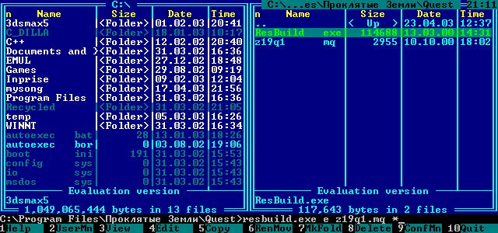

Now if you did everything right then you will have something like this
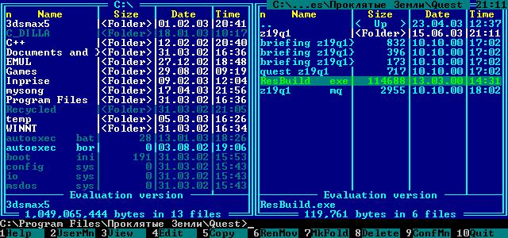

So right now you have a folder z19q1 that consists of two files: map.txt and quest.reg
First lets edit map.txt
1.Change everywhere you see z19q1 into something like z24q1.
2.Save it.
Note:that field where it says #res zone19 zone19-LMP we will leave alone unless you wish to add your personal mob (the one you have edited).

Next you open a hex edtor and load a file called quest.reg
Here you must make changes too:
1.Rename all z19q1 into z24q1
2.Save it.
Note:I don’t know if you can do the same operation with a simple text editor so you are always welcomed to try.

Now your quest.reg file should look like this (in hexworkshop)
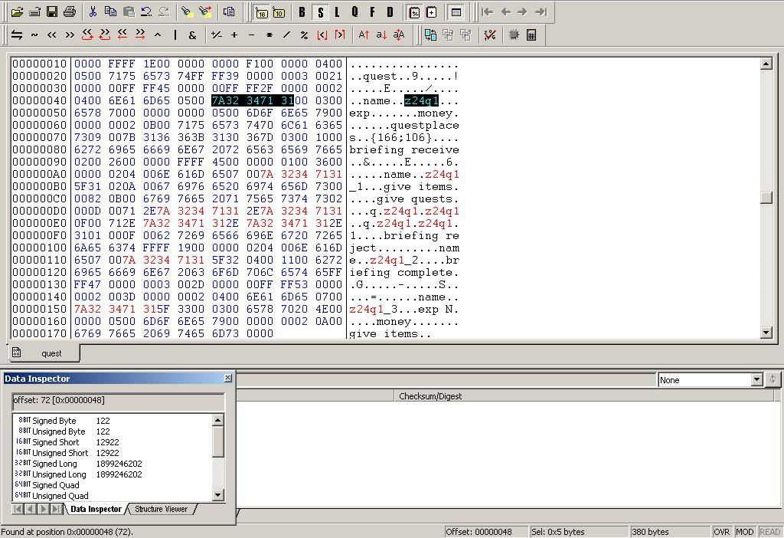

Now rename the folder z19q1 with the name z24q1.

Next step is to write your own dialogs and briefing descriptions.Sorry cant help you to write the dialogs and descriptions , this is fully your chore.But I will give you some overviews.
When you have finished editing z19q1_1,_2,_3 save them with the name z24q1_1,_2,_3.
Do the same thing to the file quest z19q1 .
Now you will have everything looking like this.
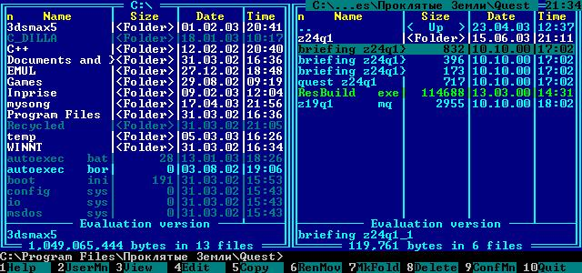
Hurray you have made it this far.
Now you have to delete your z19q1,mq file , the one who served for extraction.
Now print in resbuild.exe a z24q1.mq z24q1\*.*
Now by doing this stuff you will add a new mq file containing the info from your z24q1 folder.
Plain and simple.
The next thing we do is adding our last files.Print in resbuild.exe a z24q1.mq “briefing z24q1_1”,” briefing z24q1_2”,”briefing z24q1_3”,”quest z24q1” (all commands must be entered 1 by one ex. 1 you enter “briefing z24q1_1” then after adding it you enter the next file to add and so forth.

That’s it !! Your mq is finished !!

The last thing to do is to edit mob file (z19q1,mob) with a hex editor.Actually I don’t know if it is necessary but we will do it.Open file and make two corrections.You will have to find two text strings called as z19q1 and rename them as z24q1.Now save your mob as z24q1.

Oh you have to put your new z24q1.mq into EI map

PS.One more when you add files to your new mq you have to follow order like it was in prev. mq.
So first file to be added is briefing z24q1_1 till the quest z24q1 and the last ones will be files in the folder.

Hurray you ve made it.If you have any questions post them on the www.gipat.ru
Forums.

